INS3121
SOIL MECHANICS
FINAL MAKE-UP EXAM
February 3th, 2017

Q.1 | Q.2 | Q.3 | Q.4 | Q.5 | TOTAL
Student Name Surname:
Number:
Group:

Time is 90 minutes. Good Luck…

- Briefly describe the differences between consolidation and compaction.

- Select the correct word in the statements below regarding the internal friction angle of sandy soils.
  - The internal friction angle of sands increases / not changes / decreases with increasing relative density.
  - Well graded sands have a higher / lower internal friction than poorly graded sands.
  - Sands that have rounded grains have a higher / lower internal friction than those that have angular grains.
- Describe the following abbreviations.
  - CH :
  - SM :
  - GP :
  - I_{p} :
  - c_{u} :

- The flownet for the water seepage through a soil levee is given below. The permeability (k) of the soil is determined as 4.2x10⁻⁹ m/sec based on laboratory tests.
- Calculate the amount of seepage through the unit length of the levee.
- Calculate the water pressures at points A and B.
- Calculate the water pressures at points A and B if the water level on the upstream rises 2.0 meters due to seasonal changes. (flow net will not change)
- A plan view of ABCD foundation which carries P load is shown in left figure. A soil sample was recovered in the field and an odeometer test was performed in order to obtain consolidation properties of the clay soil. Results of the odeometer test are given in the below table. If a settlement of 10 cm is allowed at the center of the foundation, calculate the maximum column load (P_{max}) that will be carried by foundation. (Use the Boussinesq method to calculate stress increment due to foundation load).
Pressure σ_{v}′ (kPa) | Void Ratio
0 | 1.28
25 | 1.26
50 | 1.19
100 | 1.12
200 | 1.05
400 | 0.98
800 | 0.91
400 | 0.92
200 | 0.93
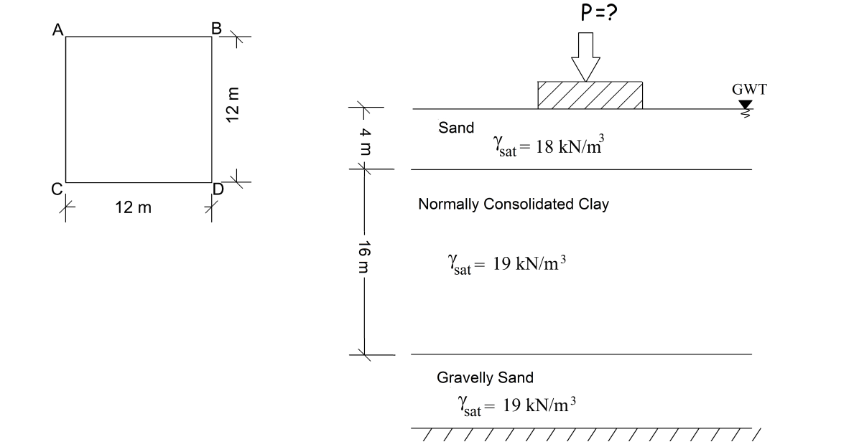
- The results of triaxial tests performed undisturbed saturated clay soil samples of same clay are given in the below table;
Test | Cell Pressure,  σ₃ (kPa) | Deviator Stress, Δσ (kPa) | Pore Pressure,  u_{f} (kPa)
CD-1 | 50 | 64 | A
CD-2 | 100 | 128.3 | B
CU | 100 | D | 34
UU | 200 | E | -
- Compute the pore water pressures developed at failure for CD tests (A and B).
- Compute the drained shear strength parameters of the clay soil according to the results obtained from the CD tests. Determine whether the soil is normally consolidated or overconsolidated clay.
- Compute the deviator stress developed at failure for CU test (D).
- If unconfined compressive strength of soil is 120 kPa, calculate the expected deviator stress developed at failure for UU test (E).
- An excavation will be made at a silty clayey to construct a 24700 m³ controlled fill in borrow area. Borrow site has a void ratio (e) 0.80 and specific gravity of solids (G_{s}) equal to 2.68. Results from a series of laboratory Standard Proctor test are given as below.
- Fill the blank cells (w, γ_{dry}) shown in the table. Draw the compaction curve in below figure and determine the optimum water content and maximum dry unit weight of the soil.
- Compute the volume of soil that needs to be excavated to obtain a 24700 m³ compacted fill considering that the specification calls for 100% relative compaction to be achieved in the field.

γ_{n}  (kN/m³) | nw (%). | γ_{dry}  (kN/m³) | e | S  (%)
17,66 |  |  | 0,623 | 38,72
19,09 |  |  | 0,529 | 55,73
20,11 |  |  | 0,477 | 73,04
19,92 |  |  | 0,511 | 76,05
19,4 |  |  | 0,565 | 73,52


